From Prototype to Production: A Hierarchical Multi-Label Customer Message Classification System
Ali Akarsu — July 2026

1 Introduction
This report documents the analysis, refactoring, evaluation and production architecture design of a customer interaction classification system. The starting point was an early prototype: a collection of scripts that loads two CSV files of customer support messages (AppGallery.csv and Purchasing.csv, 206 rows combined), cleans the text, builds TF-IDF features and trains a Random Forest to predict a single label column. The business goal is to route incoming support messages to the correct team, which requires predicting three related label levels for every message: a broad category (y2, e.g. Problem/Fault), an issue area (y3, e.g. Payment) and a specific issue (y4, e.g. Refund). The labels form a hierarchy: the meaning of y3 depends on y2, and y4 on both, which places the task in the hierarchical multi-label classification family [4], [5]. All improvements described below were implemented, executed end-to-end, and their outputs are included in the repository.

2 Analysis of the Existing Prototype
The prototype was inspected file by file. Table 1 lists the eight most significant weaknesses found, with concrete evidence from the code. The first two are the most consequential: the data leakage defect invalidates every metric the prototype reports, and the single-label design fails the core business requirement.
Issue identified | Evidence from code | Why it is a problem | Proposed improvement
Data leakage: TF-IDF fitted on the full dataset before splitting | embeddings.py: get_tfidf_embd() calls fit_transform(data) on all rows; the train/test split only happens later inside Data.__init__ (data_model.py) | The vectorizer learns vocabulary and document frequencies from the test documents, so reported metrics are optimistically biased and do not reflect performance on genuinely unseen data [1] | Split first; fit the vectorizer on the training split only and reuse it via transform() (implemented in features.py)
Single-label design despite a multi-label requirement | Config.py: CLASS_COL = "y2"; preprocess.py: df["y"] = df[Config.CLASS_COL]. TYPE_COLS = ["y2","y3","y4"] is defined but never used | The routing task needs all three label levels; predicting only y2 leaves the ticket unroutable at team level | Predict y2, y3 and y4 jointly with a multi-output design (Section 3)
Hardcoded file paths and magic values | preprocess.py: pd.read_csv("data//AppGallery.csv"); thresholds such as value_counts() > 10 inline | The pipeline cannot be pointed at new data or tested without editing source code; behaviour is undocumented | Central config.py holding every path, column name, seed and hyperparameter
No model or vectorizer persistence | No joblib.dump anywhere; randomforest.py trains, prints and discards the model | The trained model cannot be reused for inference; every prediction would require retraining, and no versioning is possible | Artefact registry: model.joblib, vectorizer.joblib and a model_manifest.json recording version, seed, data size and metrics
No input data validation | get_input_data() silently accepts ghost columns (Unnamed: 11/12 caused by trailing commas in AppGallery.csv), empty messages and duplicated rows (verbatim duplicates exist in Purchasing.csv) | Bad rows flow silently into training; failures surface far from their cause, which is the classic data-quality failure mode in production ML [2] | Fail-fast validation that reports the offending ticket ids (data_loader.py, and again before inference in predict.py)
No logging | print() statements in main.py and modelling.py only | Runs are not reproducible as evidence and cannot be monitored or audited | Python logging to console and to outputs/train_log.txt
Unpinned dependencies | requirements.txt lists bare package names | Results are not reproducible across machines or time as APIs change | Versioned requirements with tested lower bounds
Fragmented per-group training without artefact management | main.py: df.groupby(Config.GROUPED) trains a separate, unsaved model per y1 group; groups with rare classes are silently skipped (data_model.py) | A fleet of small per-group models multiplies maintenance and monitoring cost and reduces already-scarce training data per model | One unified model over all messages; revisit per-group models only if slice-level evaluation justifies it (a trade-off discussed in Section 7)
Table 1: Weaknesses identified in the initial prototype.

3 Refactored Training Pipeline
The prototype was refactored into a modular package with one responsibility per module: config.py (all paths, columns, seeds and hyperparameters), data_loader.py (loading and fail-fast validation), preprocessing.py (fixed, non-learned cleaning), features.py (learned TF-IDF features), models/ (a common BaseMultiLabelModel interface with two implementations), evaluation.py (metrics, reports, confusion matrices, error tables) and train.py (the orchestrator, run as python -m src.train). Every run is reproducible from a fixed random seed.

3.1 Ordering: the leakage fix
The single most important structural change is the order of operations. The pipeline now performs the stratified train/test split before any learned preprocessing; the TF-IDF vectorizer is fitted on the 151 training rows only and applied to the 51 test rows with transform(). Deterministic steps that learn nothing from the data (HTML unescaping, noise-pattern removal, de-duplication, label normalisation) run before the split, because applying a fixed rule to all rows cannot leak information; anything with learned state runs after it. This distinction between fixed and learned preprocessing is what makes the evaluation trustworthy [1].

3.2 Multi-label target design
The target is the triple (y2, y3, y4). Two decisions were needed. First, empty y3/y4 values (35 and 43 rows respectively in the raw data) are mapped to an explicit Unknown class rather than dropped: discarding them would remove roughly a fifth of an already small dataset, and 'not labelled at this level' is itself actionable information for a support team. Second, the label hierarchy is reflected in the model itself. Two configurations implementing a shared interface were built:
- Configuration A — Independent multi-output. One Random Forest per label level via scikit-learn's MultiOutputClassifier; each classifier sees only the TF-IDF features. This is the binary-relevance-style baseline that ignores label dependencies [3].
- Configuration B — Hierarchical chain. A classifier chain in the sense of Read et al. [3], adapted to multi-class levels: y2 is predicted from text; y3 from text plus the y2 label; y4 from text plus y2 and y3. During training each stage receives the true upstream labels; during prediction it consumes its own upstream predictions, so upstream errors propagate exactly as they would in production.
Both configurations, the fitted vectorizer and a manifest (model name, version, seed, split sizes, metrics and a UTC timestamp) are saved to artifacts/. The training script selects the serving model by hierarchical prefix accuracy, the metric that matches how the routing task consumes the labels (Section 5.1).

4 Batch Inference Pipeline
Batch inference is a separate entry point run as: python -m src.predict --input data/new_messages.csv --output outputs/predictions.csv. Before predicting anything it verifies that all required artefacts exist (model, vectorizer, manifest) and validates the input file (required columns present, no empty message bodies, offending row indices reported). The output file contains, per message: the message id, a text reference, the predicted y2/y3/y4, a per-level confidence score (the probability of the predicted class at each level), a needs_human_review flag set when any level's confidence falls below 0.50, the model name and version from the manifest, and a prediction timestamp.

4.1 Training-serving consistency
Consistency between training and serving is guaranteed by construction rather than by discipline, addressing one of the most common failure modes of production ML systems [9]:
- One preprocessing implementation. predict.py imports the same functions from preprocessing.py that train.py uses; the cleaning logic exists in exactly one place, so it cannot silently diverge.
- One learned transformer. The TF-IDF vectorizer is loaded from artifacts/ and used with transform() only; it is never re-fitted on inference data, so the feature space at serving time is identical to the one the model was trained on.
- Versioned provenance. Every prediction row carries the model version and timestamp from the manifest, so any output file can be traced back to the exact artefacts, code state and training metrics that produced it.
On the sample new_messages.csv (5 messages) the pipeline produced predictions for all rows and flagged two for human review, including a message about a failing app update that the model classified with only 0.36 confidence — a correct activation of the safety net, as discussed in Section 5.4.

5 Model Evaluation and Error Analysis

5.1 Metrics for a hierarchical multi-label task
A single flat accuracy is not meaningful when three dependent labels are predicted per message, and treating a hierarchical task as plain multi-label classification is known to obscure how errors distribute over the hierarchy [6]. Three complementary views are therefore reported. Per-label accuracy and weighted F1 measure each level in isolation. Exact-match accuracy counts a message as correct only if all three levels are right — the strictest view. Hierarchical prefix accuracy walks the levels in order (y2, then y3, then y4) and awards credit for the consecutive levels that are correct before the first mistake: a message with y2 wrong scores 0 even if y3 and y4 happen to be right, because a mis-routed top category makes the downstream labels meaningless for routing; a message with y2 and y3 right but y4 wrong scores 2/3. This mirrors the chained evaluation logic required for dependent label levels and is the selection criterion for the serving model.

5.2 Configuration comparison
Metric | Config A: independent | Config B: chained
y2 accuracy / weighted F1 | 0.824 / 0.822 | 0.824 / 0.822
y3 accuracy / weighted F1 | 0.726 / 0.734 | 0.726 / 0.739
y4 accuracy / weighted F1 | 0.745 / 0.717 | 0.726 / 0.696
Exact-match accuracy | 0.608 | 0.647
Hierarchical prefix accuracy | 0.706 | 0.726
Misclassified test messages (any level) | 20 / 51 | 18 / 51
Table 2: Test-set comparison (51 messages, stratified split, seed 0). Full per-class reports are in outputs/.
The two configurations are identical at y2 — expected, since the chain's first stage is the same model as the independent y2 classifier. The differences appear exactly where the chain differs from the baseline: conditioning y3 and y4 on upstream labels raises exact-match accuracy from 0.608 to 0.647 and hierarchical accuracy from 0.706 to 0.726, and reduces the number of messages with at least one wrong level from 20 to 18. Interestingly, Config A scores slightly higher on isolated y4 accuracy (0.745 vs 0.726): the independent y4 classifier is free to guess the globally most likely specific issue, which is sometimes right even when y2/y3 are wrong. The chain sacrifices a little isolated y4 accuracy for consistency of the full label path — and consistent paths are what the routing task needs. Whole-path metrics are the correct basis for model selection here, so Configuration B was selected for serving.

5.3 Class difficulty and imbalance
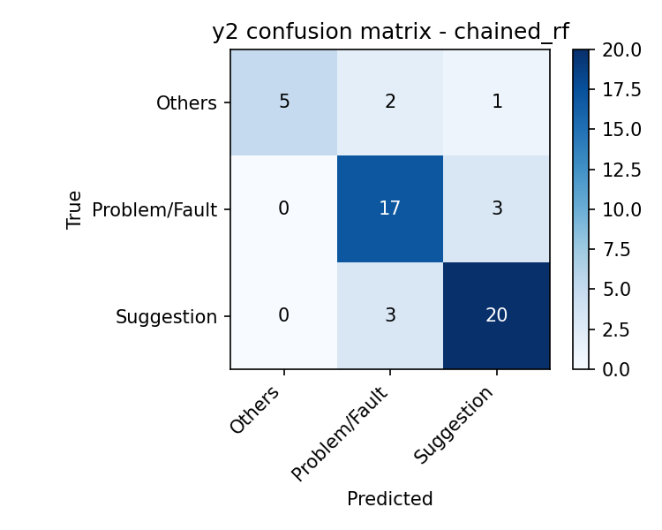
Figure 1: y2 confusion matrix for the selected (chained) configuration.
At the y2 level, Suggestion (92 raw rows) and Problem/Fault (79) are learned well, while Others (35) is the weakest class — most of its test instances are absorbed into the two majority classes (Figure 1). The effect is far stronger at y3 and y4, where the class inventories are long-tailed: several y4 classes have one or two training examples and are essentially unlearnable, a standard consequence of skewed class distributions [7]. The 'balanced_subsample' class weighting in the Random Forests softens but does not solve this. The evaluation must therefore be read with its limitations in mind: with 51 test messages, a single message changes any accuracy by roughly two percentage points; rare-class scores rest on a handful of instances; and the fixed stratification is only possible on y2, so the y3/y4 test composition varies with the seed. These limitations argue for slice-aware monitoring after deployment rather than confident claims from one split.

5.4 Error analysis
Message example (excerpt) | True labels (y2 | y3 | y4) | Predicted labels | Possible reason for error
“other download install update issue…” (app update fails to install) | Problem/Fault | AppGallery-Install/Upgrade | Other install/update issue | Suggestion | General | Personal data | Heavy noise removal leaves few tokens; remaining vocabulary overlaps with polite suggestion-style messages; whole path wrong (hierarchical score 0)
“want to cancel my subscription… charged again” | Suggestion | Payment | Subscription cancellation | Problem/Fault | Payment issue | Risk Control | Genuine label ambiguity: cancellation requests that mention an unexpected charge sit between Suggestion and Problem/Fault; annotators themselves are inconsistent here
“query deduction details for recent purchase” | Suggestion | Payment | Query deduction details | Suggestion | Payment | Subscription cancellation | y2 and y3 correct (hierarchical score 2/3); y4 confuses two payment sub-issues that share almost all vocabulary
“cannot install apps from gallery” | Problem/Fault | AppGallery-Install/Upgrade | Can't install Apps | Problem/Fault | Coupon/Gifts/Points Issues | Unknown | y3 has 10+ classes on ~150 training rows; install-related classes fragment into several fine-grained labels with few examples each
“(empty after cleaning)” — Others | Unknown | Unknown | Others | Unknown | Unknown | Suggestion | Payment | Subscription cancellation | Message content largely removed by noise filters; model falls back to majority patterns; suggests cleaning aggressiveness should be revisited
Table 3: Representative misclassifications from outputs/error_analysis_chained_rf.csv.
Which errors are most serious? In a routing system the cost of an error grows with its height in the hierarchy. A y4 error inside the correct y2/y3 (row 3 above) sends the ticket to the right team with a slightly wrong sub-tag — a minor annoyance. A y2 error (row 1) routes the ticket to the wrong department entirely, delaying a customer who reported a genuine fault. The hierarchical metric encodes exactly this asymmetry, which is why it drives model selection. The most valuable safety mechanism against the serious errors is the confidence gate: in the batch run on new messages, the one prediction that was almost certainly a y2-level mistake (an update fault classified as Suggestion) carried the lowest confidence in the batch (0.36) and was flagged for human review before it could be mis-routed.

6 Production AI System Architecture
Figures 2 and 3 show the proposed production architecture. The design intentionally keeps the local prototype's shape — the same modules become services — so the path from prototype to production is incremental rather than a rewrite.
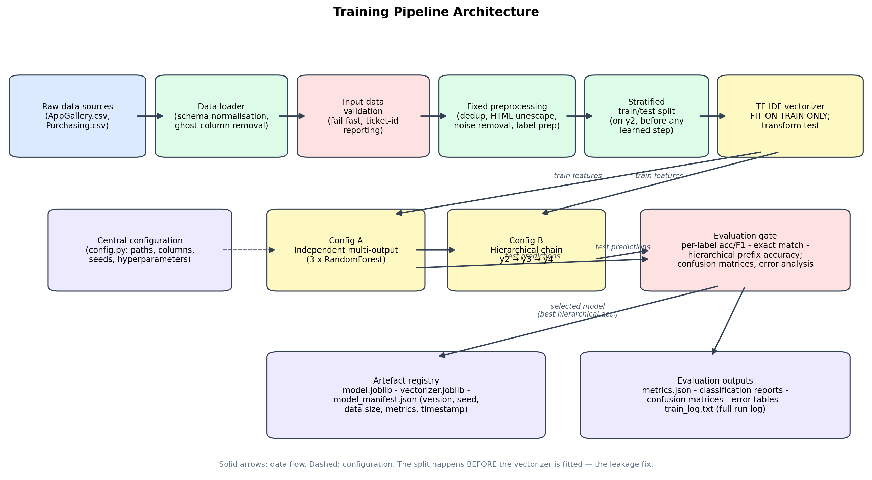
Figure 2: Training pipeline architecture.
Training pipeline (Figure 2). Raw exports land in a data store and pass through the loader and a fail-fast validation gate before any modelling. Fixed preprocessing precedes the stratified split; the vectorizer is fitted on training data only. Both model configurations are trained and must pass the evaluation gate — per-label, exact-match and hierarchical metrics plus confusion matrices and error tables — before anything is promoted. Promotion writes the model, vectorizer and manifest to a versioned artefact registry; nothing reaches serving except through this gate. A training run is fully described by (code version, data snapshot, seed, manifest), which is what makes retraining auditable [9].
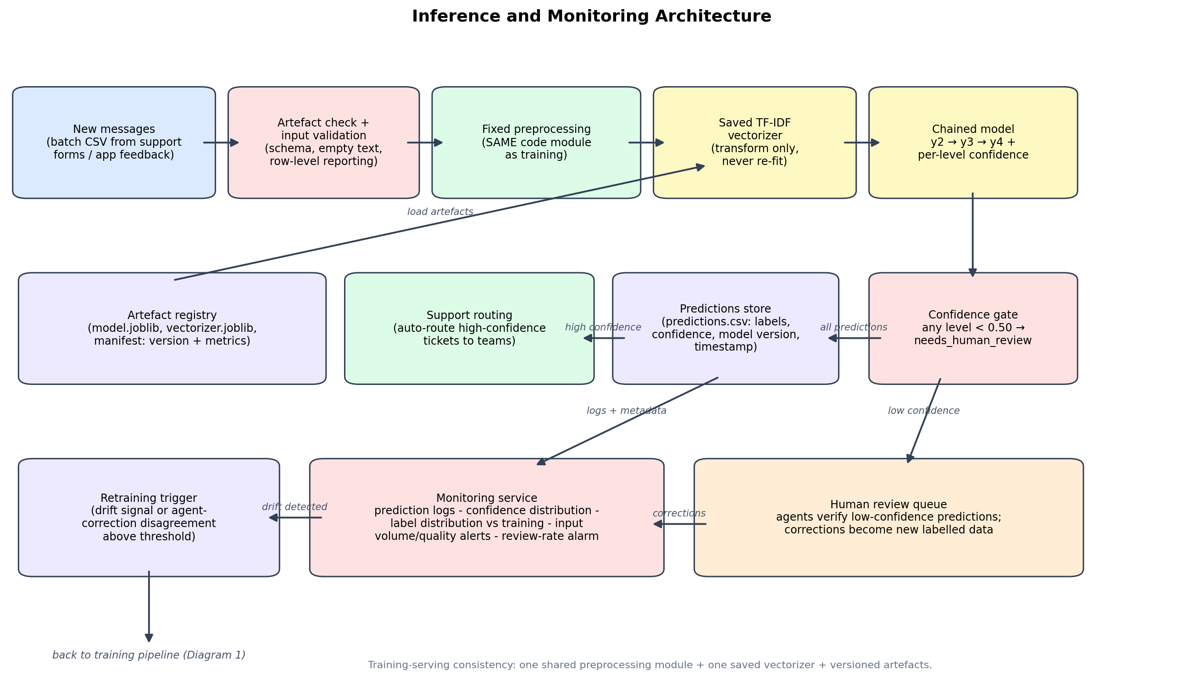
Figure 3: Inference and monitoring architecture.
Inference and monitoring (Figure 3). Batches of new messages pass an artefact-presence check and input validation, then the same preprocessing module used in training, then the saved vectorizer, then the chained model, which emits three labels and three confidences per message. The confidence gate splits the flow: high-confidence predictions are auto-routed to support teams; low-confidence ones enter a human review queue. Agent corrections from that queue accumulate as newly labelled data — the feedback loop that future retraining draws from. Every prediction is logged with its metadata to the monitoring service, which tracks confidence and label distributions against the training baseline and raises retraining triggers (Section 7).

6.1 Quality attributes
- Reliability. Fail-fast validation at both entry points; the artefact check prevents inference against missing or partial model state; the evaluation gate prevents an under-performing model from being promoted.
- Reproducibility. Fixed seeds, pinned dependencies, versioned artefacts with manifests, and logged runs; any prediction file can be traced to the exact model and code that produced it.
- Scalability. Batch inference is stateless given the artefacts, so throughput scales by sharding input files across workers. TF-IDF plus Random Forests keeps per-message cost low; the chain adds three sequential stages but each is cheap. If latency requirements tighten towards near-real-time, the same artefacts can serve an online API — the batch/online decision is a deployment concern, not a modelling one.
- Maintainability. One responsibility per module; configuration centralised; the model interface (BaseMultiLabelModel) lets a future transformer-based classifier replace the Random Forests without touching the pipeline around it.
- Safety / human oversight. The confidence threshold and review queue keep a human in the loop precisely where the model is least certain, which is where the serious routing errors concentrate.

7 Monitoring, Drift, Retraining and Trade-offs

7.1 What is logged and watched
Every prediction is logged with: message id, model name and version, timestamp, predicted y2/y3/y4, the three confidence scores, the review flag, and input-validation statistics for the batch (row counts, empty-text counts, unknown-column warnings). Three simple checks run over these logs. First, input quality: a jump in validation failures or empty-after-cleaning messages signals an upstream data problem before it becomes a model problem [2]. Second, prediction distribution: the weekly label distribution is compared with the training distribution — if Problem/Fault suddenly drops from ~40% to 10% of traffic, either the customer base changed or the model is degrading. Third, confidence and review rate: a drifting-down mean confidence or a rising share of flagged messages is the earliest observable symptom of concept drift, i.e. of a change in the relationship between message text and correct label [8]. None of these checks requires ground-truth labels, which is what makes them practical immediately after deployment.

7.2 Retraining policy
Ground truth arrives continuously and cheaply from the human review queue: every agent correction is a labelled example the current model got wrong or was unsure about. Retraining is triggered by whichever comes first: (a) the agent-disagreement rate on reviewed messages exceeding an agreed threshold for two consecutive weeks; (b) a sustained shift in label or confidence distributions as above; or (c) a scheduled quarterly refresh to absorb accumulated corrections. Retraining re-runs the full pipeline of Figure 2 on the extended dataset; the candidate model must beat the incumbent on hierarchical prefix accuracy at the evaluation gate before promotion, and the manifest records the comparison. Rollback is trivial because superseded artefacts remain in the registry.

7.3 Design trade-offs
- Chained versus independent prediction. The chain won on whole-path metrics (+0.039 exact match) and matches the task's error economics, but it costs isolated y4 accuracy (0.745 → 0.726), makes the three stages sequential rather than parallel, and propagates upstream mistakes downstream — visible in row 1 of Table 3, where one wrong y2 destroyed the whole path. We accepted error propagation because the routing task punishes inconsistent label paths more than it rewards isolated leaf accuracy [3], [6].
- Keeping sparse levels versus collapsing them. Mapping empty y3/y4 to an explicit Unknown class keeps ~20% of the data and preserves the full label structure, but it means the model spends capacity on a semantically weak class, and some y4 classes remain effectively unlearnable with 1–2 examples [7]. The alternative — collapsing rare classes into Other or predicting only y2/y3 — would raise headline metrics while silently abandoning part of the routing requirement. We chose honesty over headline numbers and flagged the tail classes as a data-collection priority rather than a modelling problem.
- Automation coverage versus review workload. The 0.50 confidence threshold flagged 2 of 5 messages in the sample batch. A higher threshold catches more y2-level errors (the expensive ones) but sends more traffic to humans, eroding the cost saving that motivated the system; a lower threshold automates more and mis-routes more. The threshold is therefore a business dial, not a constant: it should be tuned from review-queue statistics, per label level if needed, and revisited as the model improves [9].
- One unified model versus per-group models. The prototype trained a separate model per y1 group; we train one model over all messages. Unification maximises training data per model and gives one artefact to version and monitor, but it risks the majority group dominating minority-group behaviour. Slice-based evaluation over y1 groups in monitoring is the guard: if a slice degrades persistently, a per-group model for that slice is the escalation path.
A final risk worth naming: support messages contain personal data, and both the training corpus and the prediction logs are sensitive stores. Access to the artefact registry and logs must be restricted, since trained models and shared datasets can themselves leak properties of the underlying data [10], and retention of raw message text in logs should be minimised in line with data protection obligations.

References
[1] M. Rosenblatt, L. Tejavibulya, R. Jiang, S. Noble, and D. Scheinost, “Data leakage inflates prediction performance in connectome-based machine learning models,” Nature Communications, vol. 15, art. no. 1829, 2024.
[2] E. Breck, N. Polyzotis, S. Roy, S. E. Whang, and M. Zinkevich, “Data validation for machine learning,” in Proceedings of Machine Learning and Systems (MLSys), 2019.
[3] J. Read, B. Pfahringer, G. Holmes, and E. Frank, “Classifier chains for multi-label classification,” Machine Learning, vol. 85, no. 3, pp. 333–359, 2011.
[4] A. Zangari, M. Marcuzzo, M. Rizzo, L. Giudice, A. Albarelli, and A. Gasparetto, “Hierarchical text classification and its foundations: A review of current research,” Electronics, vol. 13, no. 7, art. no. 1199, 2024.
[5] R. Liu, W. Liang, W. Luo, Y. Song, H. Zhang, R. Xu, Y. Li, and M. Liu, “Recent advances in hierarchical multi-label text classification: A survey,” arXiv preprint arXiv:2307.16265, 2023.
[6] R. Plaud, M. Labeau, A. Saillenfest, and T. Bonald, “Revisiting hierarchical text classification: Inference and metrics,” in Proceedings of the 28th Conference on Computational Natural Language Learning (CoNLL), 2024.
[7] D. Ramyachitra and P. Manikandan, “Imbalanced dataset classification and solutions: A review,” International Journal of Computing and Business Research, vol. 5, no. 4, 2014.
[8] J. Lu, A. Liu, F. Dong, F. Gu, J. Gama, and G. Zhang, “Learning under concept drift: A review,” IEEE Transactions on Knowledge and Data Engineering, vol. 31, no. 12, pp. 2346–2363, 2019.
[9] F. Bayram and B. S. Ahmed, “Towards trustworthy machine learning in production: An overview of the robustness in MLOps approach,” ACM Computing Surveys, 2025, doi: 10.1145/3708497.
[10] W. Zhang, S. Tople, and O. Ohrimenko, “Leakage of dataset properties in multi-party machine learning,” in Proceedings of the 30th USENIX Security Symposium, 2021.

